GDraw

The program is designed to be used in a non-linear way. There will be no "menu screen" like in programs such as games; instead the user will be able to immediately start using it to draw. Such a menu screen would be unnecessary for a drawing program.

The user will start with a blank canvas and with the Pencil tool activated. The user can switch to other tools or adjust the current tool (varies with the tool being used) easily by pressing certain hotkeys (listed in the manual included with the program). A GUI that includes a basic toolbar, cursor position, tool adjustments and tool descriptions is under development but may not be completed in time.

Many variables are used by GDraw, at least 70 at the time of January 9. This document will not include a list of all variables, as that would be an unnecessarily large list. Only the main 'configuration' variables and other commonly used ones will be included.

Generally, dictionaries are used to improve efficiency of key inputs (i.e. using 3 lines of code to change the radius of a pencil using keys 1-0 instead of over 15 lines) or for formatting. All of these variables are documented within the program file when their intended purpose is not immediately obvious.

This is a list of global variables that are either commonly used or affect various tools or the program.

Configuration/Settings Variables
- Config, Settings – Used to acquire window resolution & pencil offset distance from a settings file
- Icon, window – Former is self-explanatory, latter is used to create a window using the resolution settings
- Canvas, Toolbar, InfoBar – pygame surfaces. As of Jan 9 only the Canvas is fully integrated.
- running – allows the program to loop…
- Ruler, RulerX, RulerY, SavedX, SavedY – These are used by the Ruler to allow drawing in a straight line
- Color – The color that all tools except Eraser will draw with
- Mode – The tool currently enabled
- Cursor_Strings, Cursor_Data – Allows a 24x24 crosshair-shaped cursor to be used
- Tools
Pencil – PencilType (shape), PencilSize (radius), PencilOffset (distance), PencilColorSet (use either Color or a random RGB), Pencils (offsets), AlwaysDraw (toggle to draw without clicking)
Eraser – EraserType (shape), EraserSize (radius), AlwaysErase (toggle to erase without clicking)
Eyedropper – EyedropperStarted (allows it to only take one value per click)
Palette – Palette_Values (stores RGB values as a string before conversion)
Line – LineWidth (self-explanatory), LineStarted (needed to allow a user to draw a line from xy1 to xy2)
Shapes (Square,Rect,Circle,Ellipse) – ShapeStarted (similar to LineStarted), ShapeType (filled or outline)
Information/Calculations
- Events – List of input events taking place
- MousePos, MouseX, MouseY, Buttons – Position of the cursor and status of mouse buttons
- KeyMod – Modifier keys pressed (alt, shift, ctrl, etc.)

Sample output screenshots of the current version (as of Jan. 09) are on the page below.

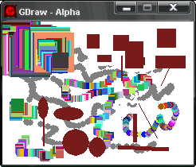
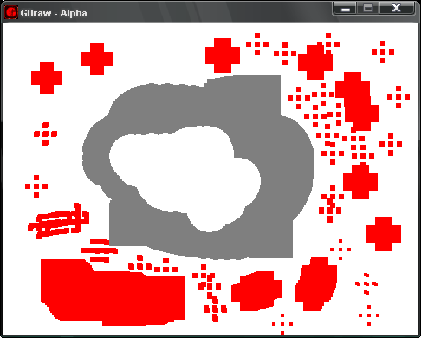
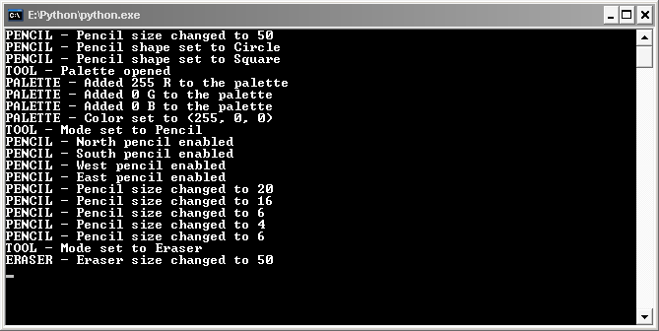
Demo of the pencil, including both pencil shapes, different pencil sizes and the random colour scheme. Also includes demos of the Line, Rectangle and Ellipse tools.
Demo of pencil offsets and eraser on a larger window. Window size can be changed by editing the file "gdraw_config.ini"
Sample output on the Python CLI. Most tool adjustments, such as adjusting pencil size, display a message when successfully made. Core mechanics such as drawing do not.

